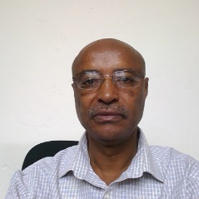

About College of Natural and Applied Science
Siraye Esubalew Debebe (PhD)
Dean, College of Natural and Applied Sciences

College of Natural and Applied Sciences is one of the three colleges of Addis Ababa Science and Technology University.

We are committed to produce highly competent, quality and world-class manpower in science and technology.

The college has four departments and one division under its authorization. These are Biotechnology, Food Science and Applied Nutrition, Geology and Industrial Chemistry departments and Mathematics, Physics and Statistics division.

In order to provide quality education, the college capacitate each department to have furnished laboratories. Moreover, the college engage students in field works and practice in Industries to introduce them to the real working environment. It also enforces every academic staff to participate in continuous professional development programs to became high level trainers.
In order to assure the standards of the degrees it provides, the college is working to accredit each department undergraduate programs by ABET, which is a non-government organization based in United State of America.

The college works industriously to satisfy the needs of the industry, the community and government sectors who are in need of quality graduates.

